ASSIGNMENT-3

|  |  |
| --- | --- |
| Date | 03 October 2022 |
| Team ID | PNT2022TMID30006 |
| Project Name | Cloud Computing – Nutrition Assistant |

PYTHON PROGRAMMS IN SPYDER:

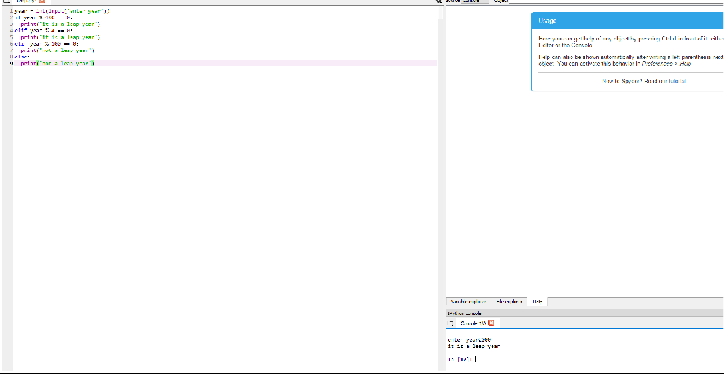

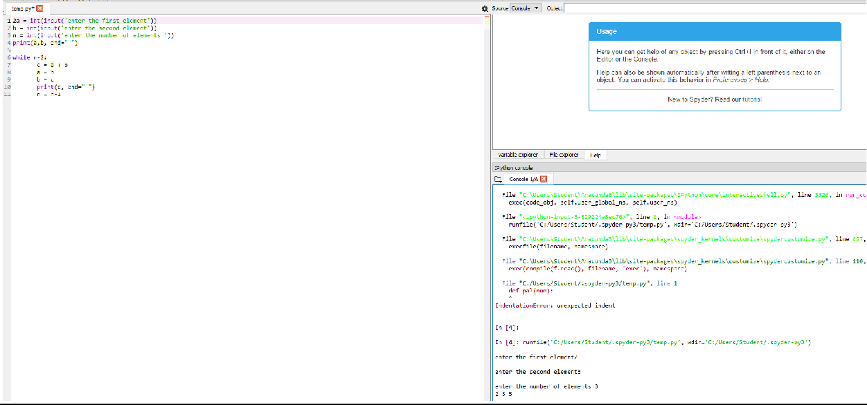

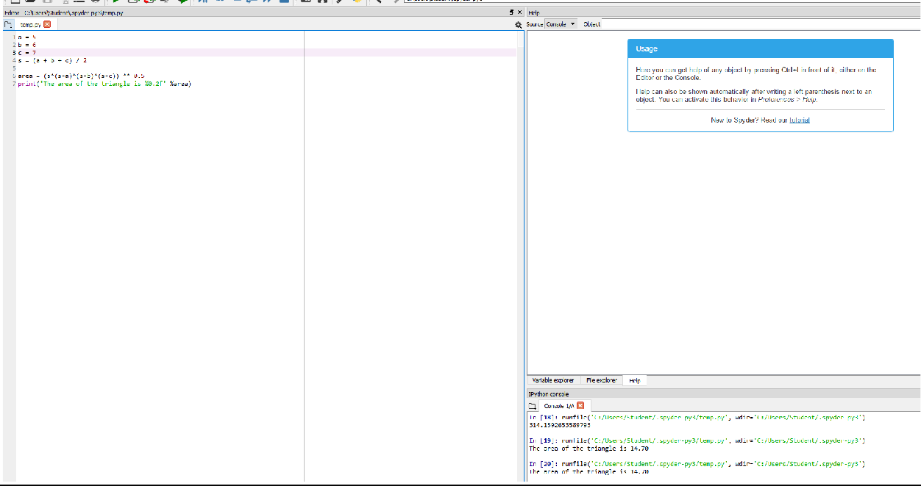

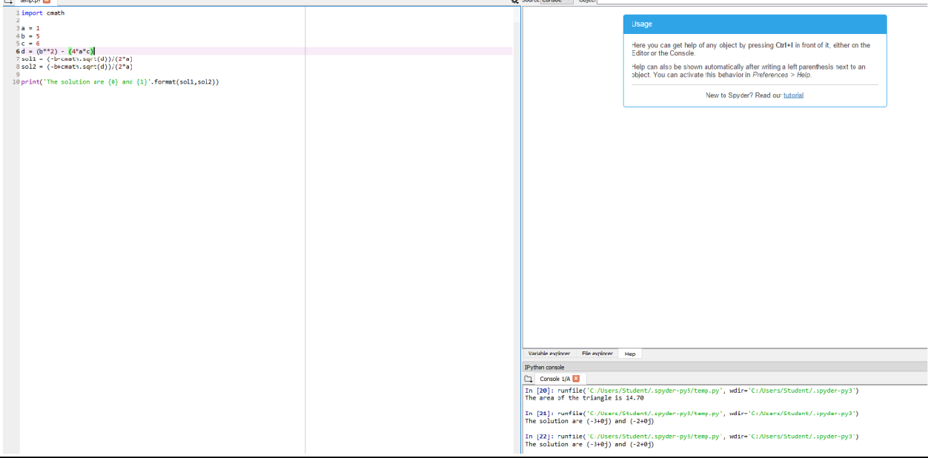

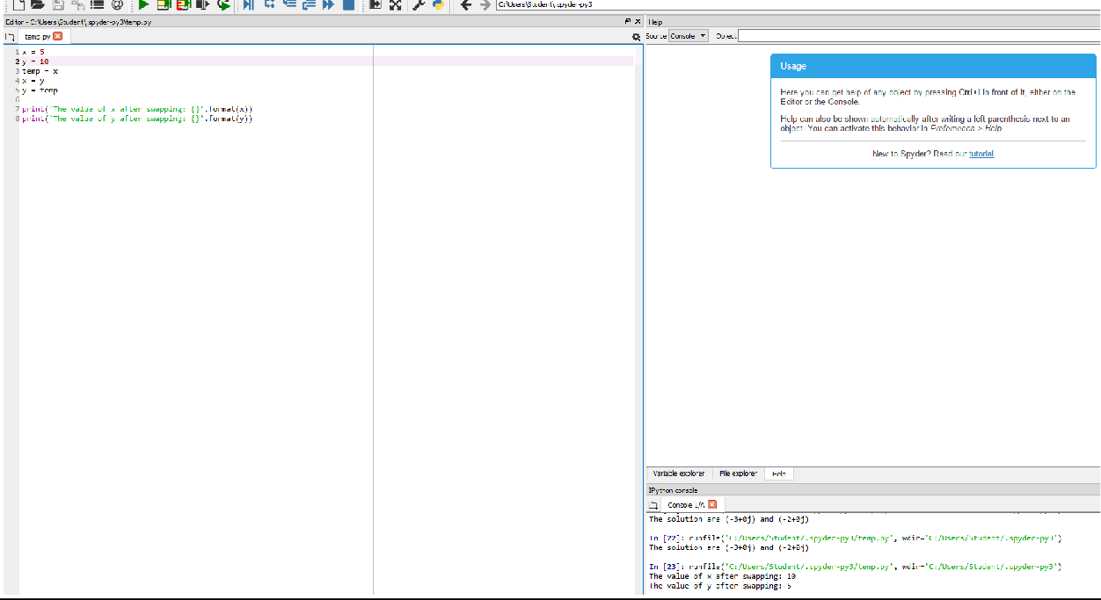

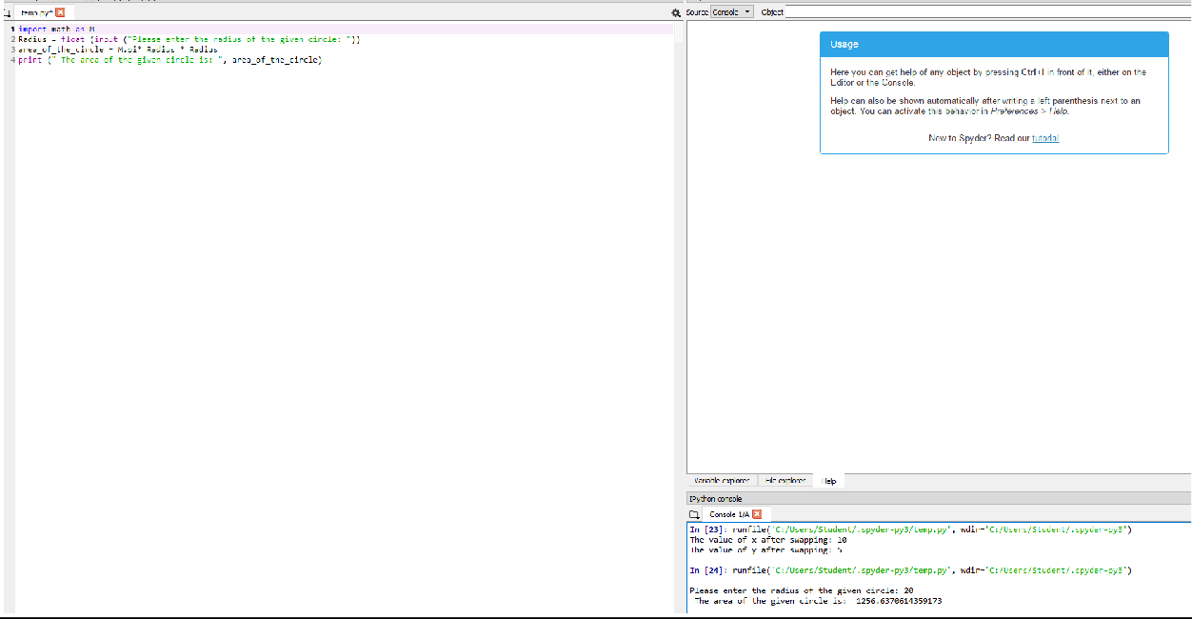

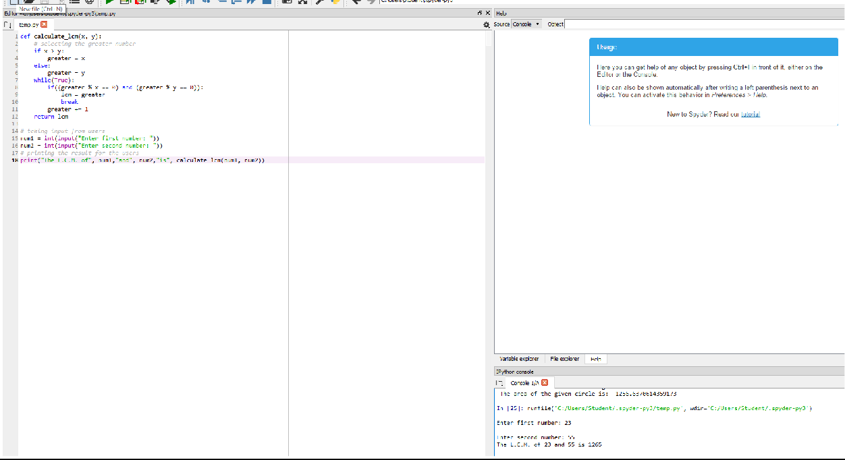

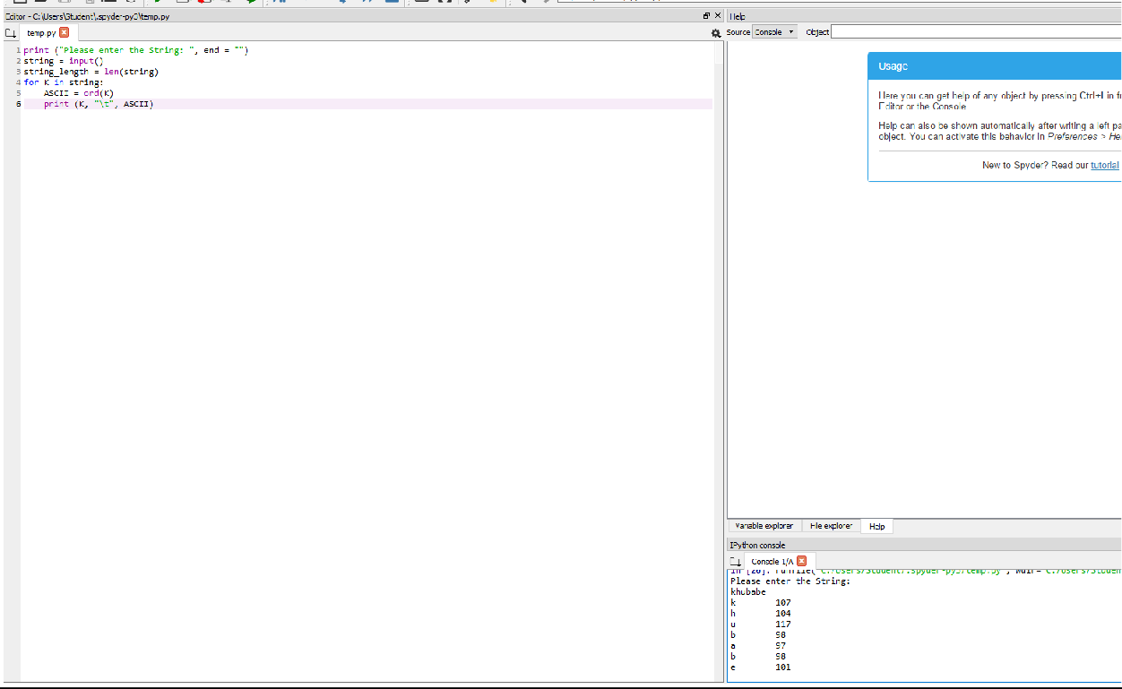

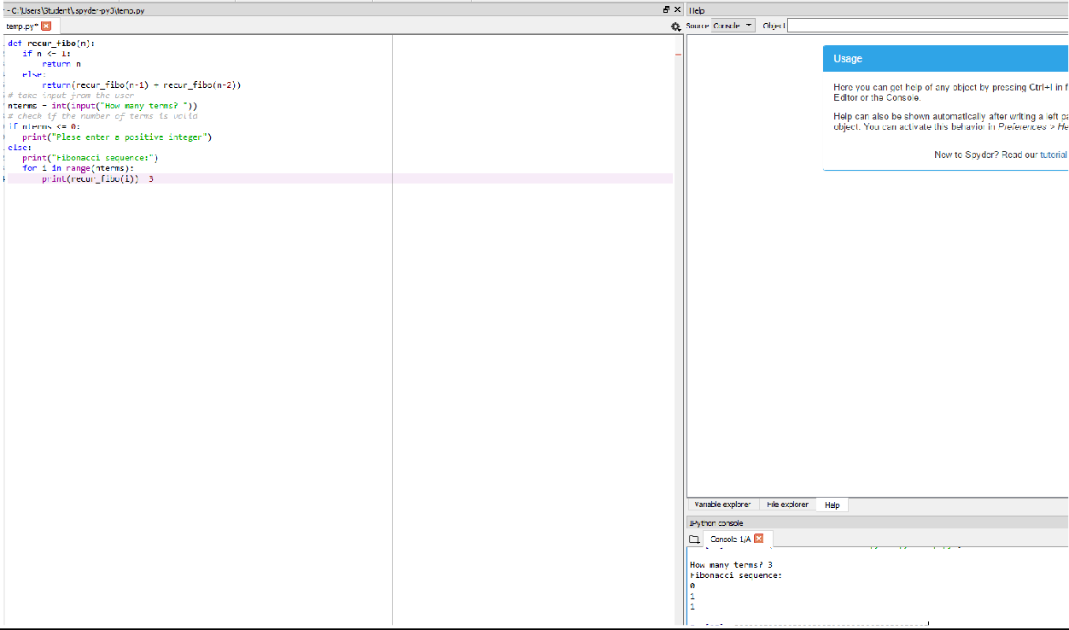

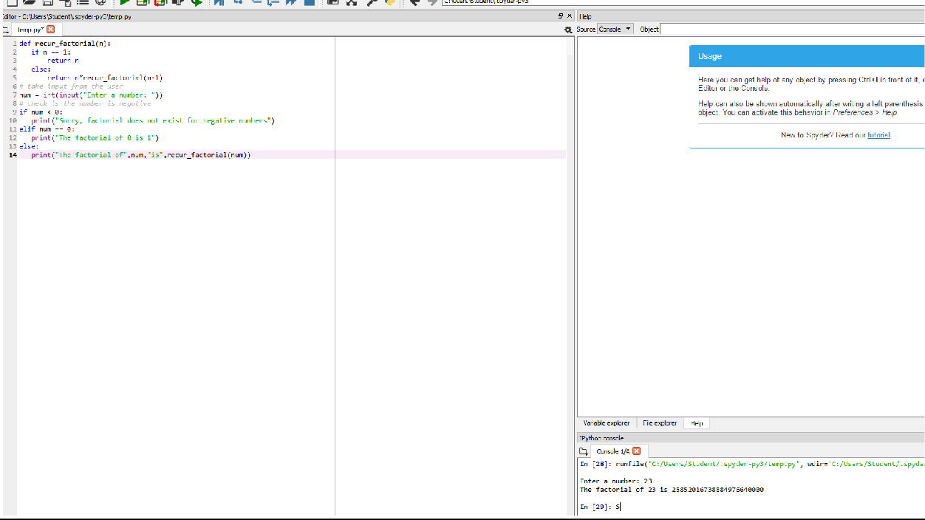

2.FLASK PROGRAM:

>>> import emoji

>>> print(emoji.emojize('Python is :thumbs_up:'))

Python is 👍

>>> print(emoji.emojize('Python is :thumbsup:', language='alias'))

Python is 👍

>>> print(emoji.demojize('Python is 👍'))

Python is :thumbs_up:

>>> print(emoji.emojize("Python is fun :red_heart:"))

Python is fun ❤

>>> print(emoji.emojize("Python is fun :red_heart:", variant="emoji_type"))

Python is fun ❤ #red heart, not black heart

>>> print(emoji.is_emoji("👍"))

True

>>> print(emoji.emojize('Python es :pulgar_hacia_arriba:', language='es'))

Python es 👍

>>> print(emoji.demojize('Python es 👍', language='es'))

Python es :pulgar_hacia_arriba:

>>> print(emoji.emojize("Python é :polegar_para_cima:", language='pt'))

Python é 👍

>>> print(emoji.demojize("Python é 👍", language='pt'))

Python é :polegar_para_cima: